  AUCHAN DOSI  Cash Register Domain |  |  | Draft  02/09/2005
 | Installation Guide for Host OutSqribe82 |  | Draft  02/09/2005

Versions | Version | Writer | Date | Modification
 | 1.0 | Julien MARGA | 02/09/05 | Translation

Approval | Name | Function | Date
 | Bertrand SANSSE

Diffusion | Name | Function | Date

Table of contents

1 Hyperion SQR Server : Installation procedure 3
2 Hyperion SQR Activator : Installation procedure 10
3 Manual operations 16

Hyperion SQR Server : Installation procedure
The goal of this procedure is to help you during the Hyperion sqr server v8.2 install process.
Into \sqr82\win\sqr82Winora, please launch setup.exe.
Then, follow the instructions :

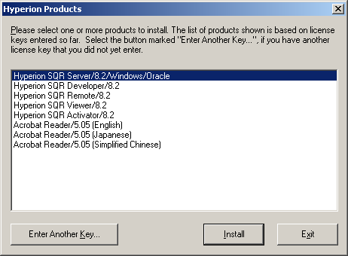

Choose Hyperion SQR Server/8.2/Windows/Oracle.
Clic on the Install button.

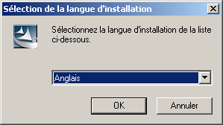

Choose Anglais for using english as installation language
Clic on the OK button.

The key product is 3L01-657FQ-0HHVO
Clic on the Next button.

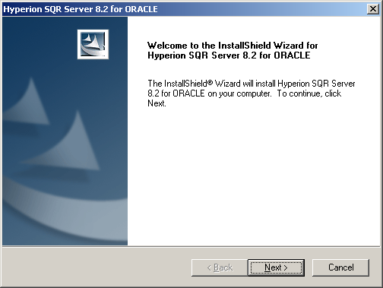

Clic on the Next button.

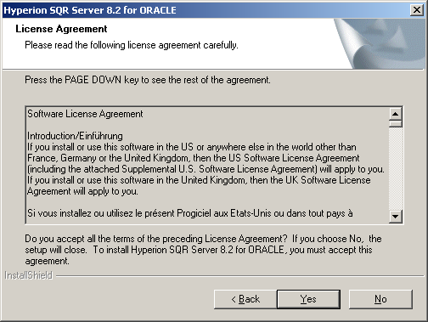

Accept the license agreement by a clic on the Yes button.

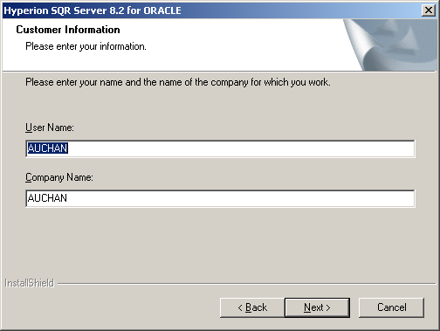

Clic on the Next button.

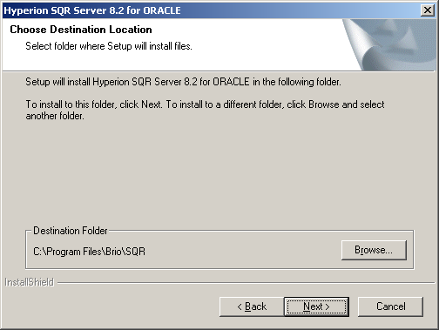

the destination folder is C:\Program Files\Brio\SQR
Clic on the Next button.

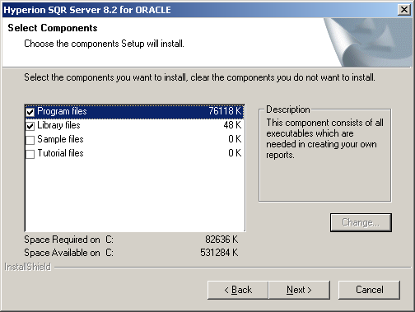

Select the Program files and Library files components.
Clic on the Next button.

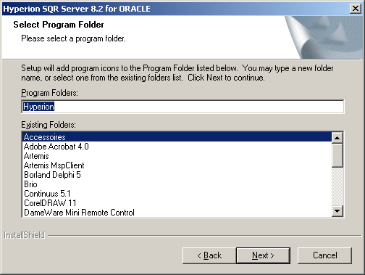

Clic on the Next button.

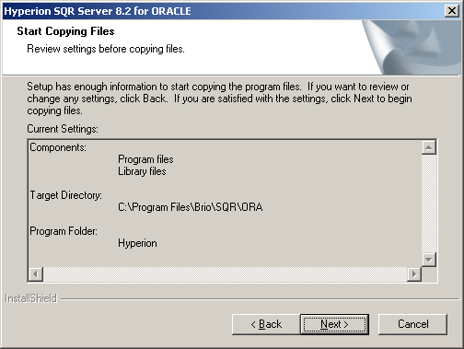

Clic on the Next button.

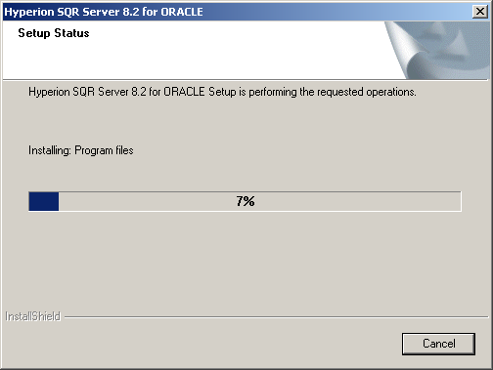

Sqribe is installing.

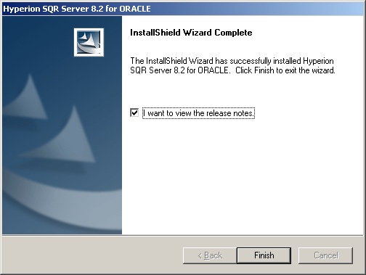

When the install process ends, clic on the Finish button.

Hyperion SQR Activator : Installation procedure
Into \sqr82\win\Activator_82, launch Setup.exe :

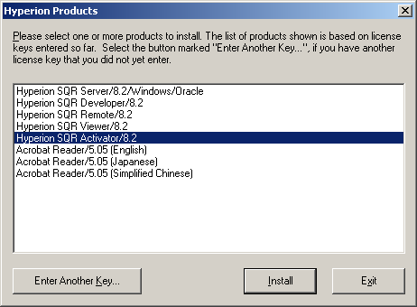

Choose Hyperion SQR Server/8.2/Windows/Oracle.
Clic on the Install button.

Choose Anglais for using english as installation language
Clic on the OK button.

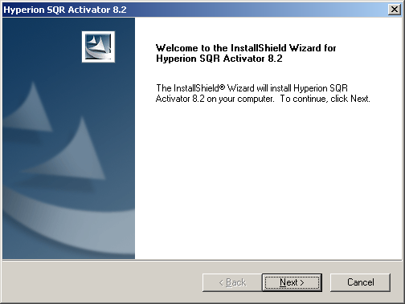

Clic on the Next button.

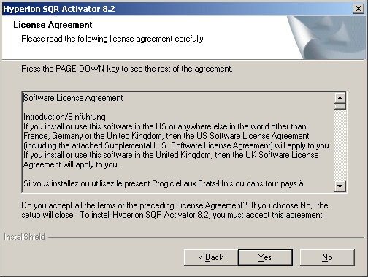

Clic on the Yes button.

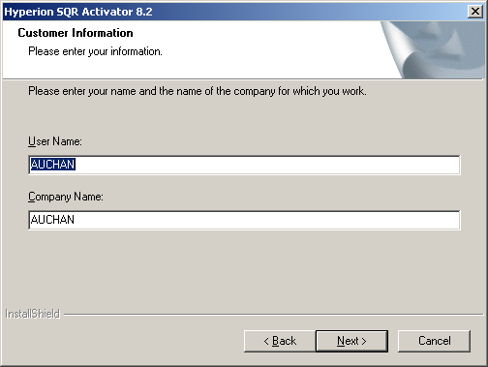

Clic on the Next button.

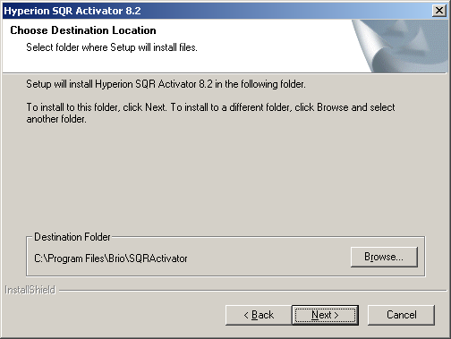

Choose C:\Program Files\Brio\SQRActivator as destination folder.
Clic on the Next button.

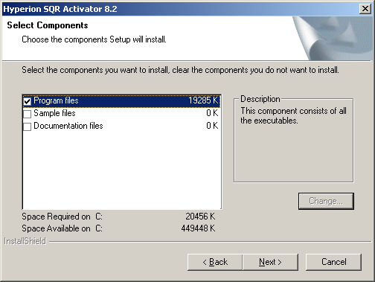

Select the Program files component.
Clic on the Next button.

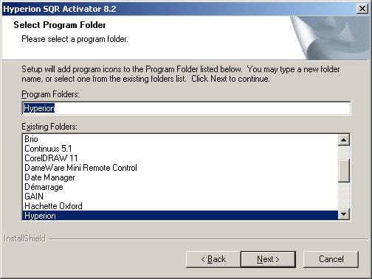

Clic on the Next button.

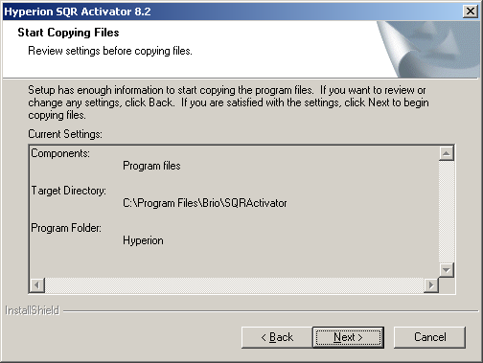

Clic on the Next button.

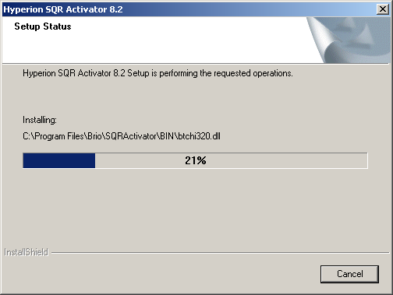

Sqribe Activator is installing.

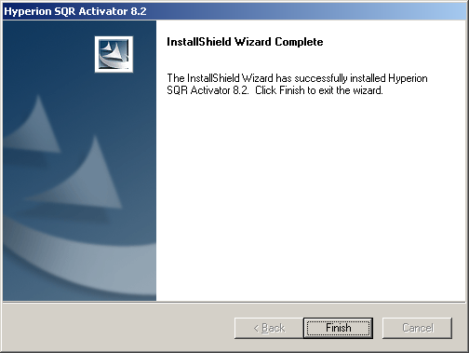
When the install process ends, clic on the Finish button.

Manual operations

1/ Replace the postscri.str file into C:\Program Files\Brio\SQR\ORA\BINW\ with the one from \sqr82\win\

2/ Replace the SQR.ini file into C:\WINNT\ with the one from \sqr82\win

3/ Finally, update the PATH environment variable, replacing the old sqribe 6.1.4 acces path with C:\Program Files\Brio\SQR\ORA\BINW\

Execute sqrw into a MS-DOS command window. If the install has been correctly processed, Sqribe8.2 should be executed.

